Planning Models Graphic Organizer Assignment
Part One:
Direction: Using your notes and textbook, compare and contrast the three planning models you learned in the lesson: Task Analysis Model, Concept Analysis Model, and Advance Organizer Model. List three differences as well as three similarities for these models.
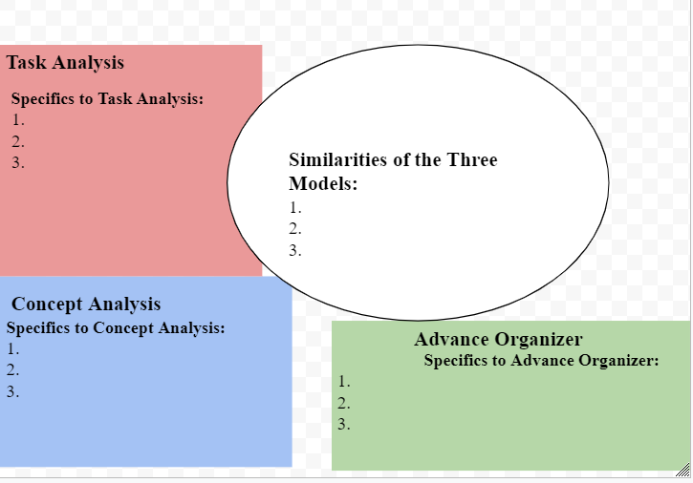

Part Two
